- We expect the Monetary Policy Committee to keep Bank Rate at 3.75% at its next meeting on April 30.
- Most MPC members appear content with holding policy at its current restrictive level as they wait for more information about how the energy shock is feeding through to the economy. But we suspect a minority may opt for a 25bp rate hike on the basis that they view some pre-emptive tightening as a more robust strategy to guard against a wide range of inflation paths where the risks are skewed to the upside.
- The MPC will incorporate the impact of the Middle East conflict into its forecast and provide a new set of scenarios. With uncertainty still elevated, how individual members position themselves relative to these scenarios will be a key signal of how they view the balance of risks around the new baseline forecast.
The Bank of England’s Monetary Policy Committee held Bank Rate at 3.75% at its most recent meeting on March 19. Although the outcome was widely expected, with committee members agreeing it was too soon to draw firm conclusions on the appropriate policy response to the outbreak of the US/Israel-Iran war, financial markets interpreted the unanimous vote and guidance very hawkishly.
March’s minutes were non-committal on the direction of the next policy move, and remarks from MPC members since then suggest the majority want to wait for more data before taking a strong view on the implications of the conflict for monetary policy. Therefore, we expect Bank Rate to remain unchanged again next week, with the real interest centring on a new set of scenarios and whether enough MPC members would be actively open to the prospect of a summer rate hike should energy prices remain elevated or rise further.
Chart 1: A majority of MPC members appear to be adopting a ‘wait and see’ approach for the time being
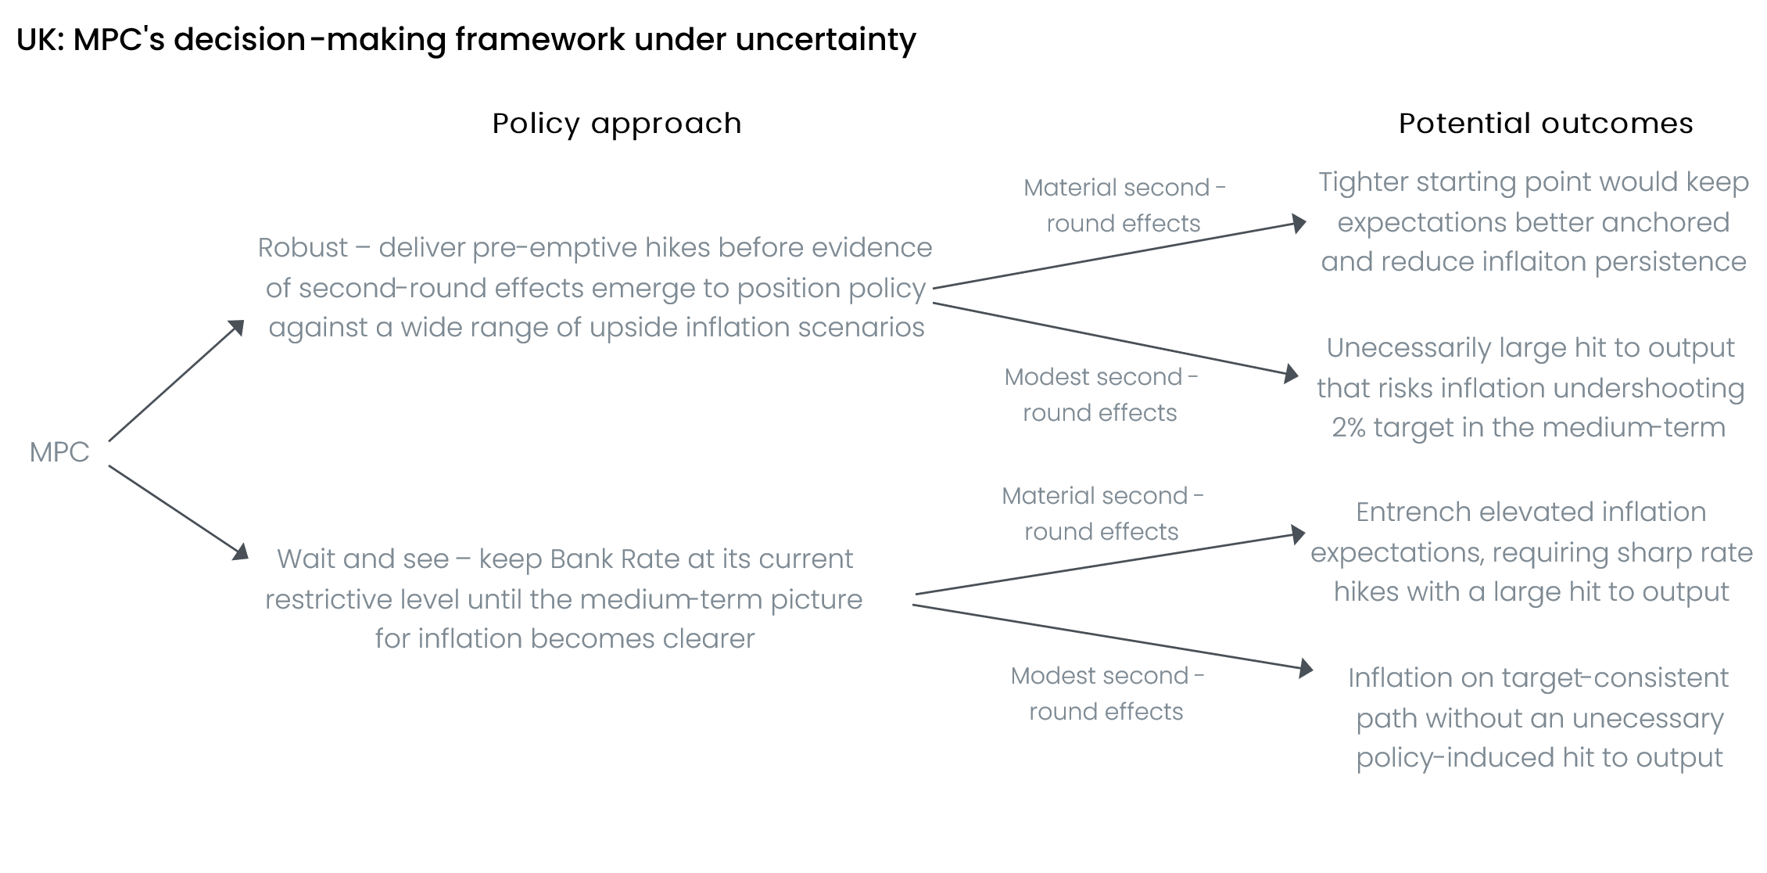
Source: Oxford Economics

Most MPC members have spoken since the March meeting to detail how the adverse supply shock emanating from the Middle East is influencing their thinking (Table 1 shows our analysis of recent comments by committee members). With the scale of any second-round effects of higher inflation on pay growth and firms’ pricing strategies very uncertain, tensions are emerging amongst policymakers over what is the most preferable policy response to return inflation to the 2% target sustainably over the medium term (Chart 1 sets out the strategies and potential outcomes).
Table 1: Key comments by MPC members
Speaker and link | date | Key takeaway | Expected decision
Bailey | April 15 | Bailey emphasised the need to wait for more information before taking a strong view on the implications of the conflict for monetary policy, saying that “we’re not going to rush to judgments on those things, because there are a lot of uncertainties”. This signals he’s likely to vote for a hold at next week’s meeting. | Hold
Greene | April 14 | Greene was characteristically hawkish, arguing that it would be a significant risk to wait for clear evidence that significant second-round effects were materialising. She also suggested that the market position — which at the time implied two 25bp rate hikes by the end of this year — was “about right”. This suggests there’s a good chance she votes for a 25bp rate hike at one of the next few meetings. | +25bps
Mann | April 14 | In a panel event at Aon, Catherine Mann said that she didn’t think inflation would hit the BoE’s 2% target “in the near term or the longer term”. This indicates she’s likely to vote to tighten policy in the near term. | +25bps
Breeden | March 26 | Breeden signalled that she remained in ‘wait and see’ mode, noting that “it’s not wise to act before we have sufficient information”. She also downplayed the risks of second-round effects emerging, highlighting the degree of slack in the economy and that firms and workers now have much less pricing and bargaining power than during the 2022-2023 inflation episode. | Hold
Taylor | March 26 | Taylor said that a combination of elevated uncertainty around future energy prices and the economy’s relatively soft starting point means he sees a high bar to raising Bank Rate. In his view, holding policy steady remained preferable until the impact of the conflict becomes clearer. | Hold
Pill | March 24 | The BoE’s Chief Economist suggested that pre-emptive rate hikes may be a more robust approach to setting policy if inflation risks are skewed to the upside and the cost of policy errors is asymmetric. He also said, “I’m not sure waiting is necessarily the appropriate response to the sort of inflation dynamics which have the potential at least to have some self-sustaining momentum”. We think there’s a strong possibility of Pill voting for a rate hike in the near term. | +25bps
Ramsden | N/A | No comments | Hold
Lombardelli | N/A | No comments | Hold
Dhingra | N/A | No comments | Hold
Source: Oxford Economics
In the face of elevated uncertainty, most committee members appear to be adopting an approach of keeping Bank Rate at its current restrictive level while they wait to see if significant second-round effects start to materialise. Indeed, Governor Andrew Bailey remarked earlier this month that he wasn’t going to rush into any judgements, while Sarah Breeden and Alan Taylor have both strongly signalled that they view holding policy steady as preferable.
The ‘wait and see’ strategy is predicated on the view that activity is fragile and any second-round effects are likely to be much smaller than those seen during the 2022-2023 episode. This is because there’s now far more slack in the economy, which limits firms' pricing power and workers' bargaining power in wage negotiations. At the same time, the current policy is already somewhat restrictive, and there’s also much less scope for fiscal policy to support activity in the same way as it did at the time of the previous energy shock. Therefore, any pre-emptive rate hikes carry the risk of pushing the economy into an unnecessary recession, which could see inflation undershoot the 2% target in the medium term.
Uncertainty around the scale of second-round effects of higher inflation on pay growth is unlikely to be resolved quickly, as most annual pay deals are set during the January-April period each year. Therefore, some committee members have argued that waiting for second-round effects to materialise in the data risks the MPC falling behind the curve. As we highlighted in a Research Briefing earlier this week, members such as BoE Chief Economist Huw Pill have suggested that it may be more preferable to adopt a ‘robust’ strategy that sets policy in a way that aims to ensure outturns for inflation and output are not too bad across a wide range of scenarios for energy prices and second-round effects.
For the committee’s more hawkish members, who have long argued that recent structural changes in price- and wage-setting have introduced additional upward pressures for inflation, a ‘robust’ strategy probably points to some pre-emptive rate hikes. This is partly on the basis that these members view the balance of risks around the medium-term inflation outlook as skewed to the upside. But we also suspect these members probably think it would be less costly to overtighten this year and reverse course if needed, than to risk the MPC being behind the curve again should significant second-round effects emerge.

Recent data offer few insights to the MPC
We’re still in a position where most of the hard data refers to the period before the Middle East war began, so it’s difficult to confidently judge how the energy shock is feeding through to the economy. At the same time, more timely survey data have shown a mixed picture for how price and wage pressure are evolving. The S&P Global surveys for March and April signalled that higher fuel and energy costs had led to a significant increase in input costs for firms. However, businesses don’t appear to be fully reflecting the spike in cost pressures in output prices for customers yet.
The degree to which the energy shock will ultimately pass through to other prices and pay settlements will partly depend on how well-anchored inflation expectations are. March’s Citi/YouGov survey of inflation expectations reported sharp rises in its measures of short- and long-term household inflation expectations. However, the results of the BoE’s own Decision Maker Panel for March were less concerning. Firms’ year-ahead inflation expectations rose much more modestly, while the measure of firms’ medium-term inflation expectations was virtually unchanged. Companies also reported little movement in their expectations for wage growth over the next year.

The MPC’s forecast update will reflect the energy shock, but new scenarios will be more important
The near-term inflation outlook had started to brighten around the turn of the year, but the conflict in the Middle East, and particularly the disruption to shipping through the Strait of Hormuz, have thrown a major spanner in the works. The MPC’s April forecast will be the first since the conflict started and will incorporate the sharp rises in oil and gas futures prices (Chart 2). Our analysis suggests the shift in these conditioning assumptions alone will lift the MPC’s CPI inflation forecast by more than a percentage point by the end of the year, compared with the February forecast. The MPC will also have to make a judgement about the speed and scale of the passthrough of higher fuel and energy costs for businesses to other parts of the inflation basket, such as food prices, and the more energy-intensive components of core inflation.
Chart 2: The MPC’s updated forecasts will assume significantly higher oil and gas prices
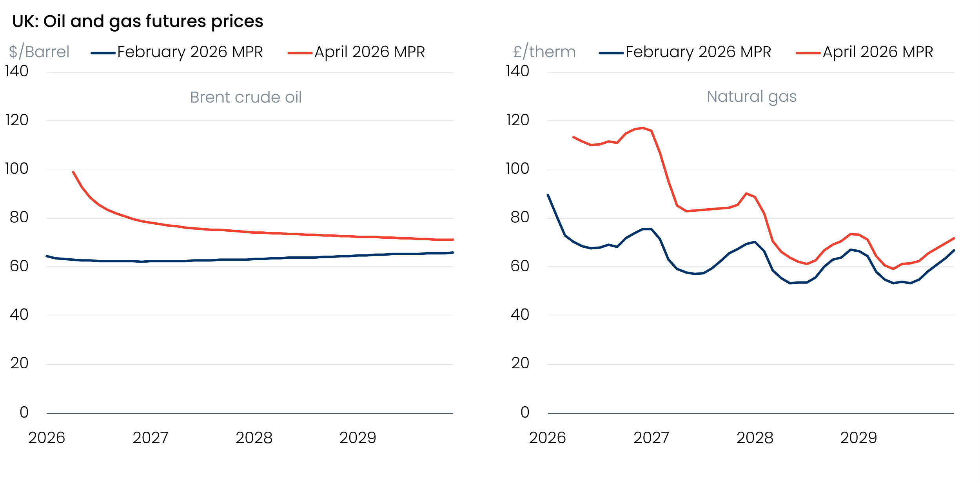
Source: Haver Analytics
Favourable historical revisions and a much stronger-than-expected Q1 mean the MPC’s new GDP projection will start from a higher level. But stronger inflation will weigh heavily on real household incomes and consumer spending. At the same time, weaker business confidence and corporate profitability will hurt business investment. These downward forces will be supplemented by a significant tightening in financial conditions. Therefore, there’s a good chance that the MPC’s 2026 GDP growth forecast falls to around 0.5%, from 0.9% in the February forecast. Meanwhile, the MPC’s projection for 2027 is likely to dip below 1%, from 1.5% previously.
Given the heightened uncertainty around the outlook, we suspect most MPC members will place less weight on the updated baseline forecast than usual, and instead make greater use of a new set of scenarios. These will likely be based on alternative paths for commodity prices and the scale of second-round effects on pay growth and firms’ pricing strategies.
We suspect a more hawkish scenario could lean on the view that a combination of higher energy prices and a further rise in inflation expectations risks generating much greater persistence in price- and wage-setting, requiring a material tightening of policy to sustainably return inflation to target. Meanwhile, a more dovish scenario may suggest that the negative demand shock from higher energy prices will dominate, and with second-round effects likely to be modest, inflation risks undershooting the 2% target in the medium term without a more accommodative policy stance over the next couple of years.
The BoE staff will also likely provide a collection of estimated optimal policy paths under the new alternative scenarios. Therefore, how individual committee members position themselves relative to the new scenarios will be a key indicator of how they view the balance of risks around the updated baseline forecast.

A hold in April is very likely, while the July meeting is set to be the next with genuine jeopardy
Several MPC members have stressed the importance of keeping policy steady while they wait for more data, including Governor Bailey who is usually a good bellwether of MPC sentiment. This strongly suggests to us that a majority will vote to hold Bank Rate at 3.75% again at the April meeting. Financial markets agree – as of April 23, market pricing implied just 13% chance of a 25bp rate hike at next week’s meeting (Chart 3).
Chart 3: Markets have taken on a less hawkish view of interest rates in recent weeks
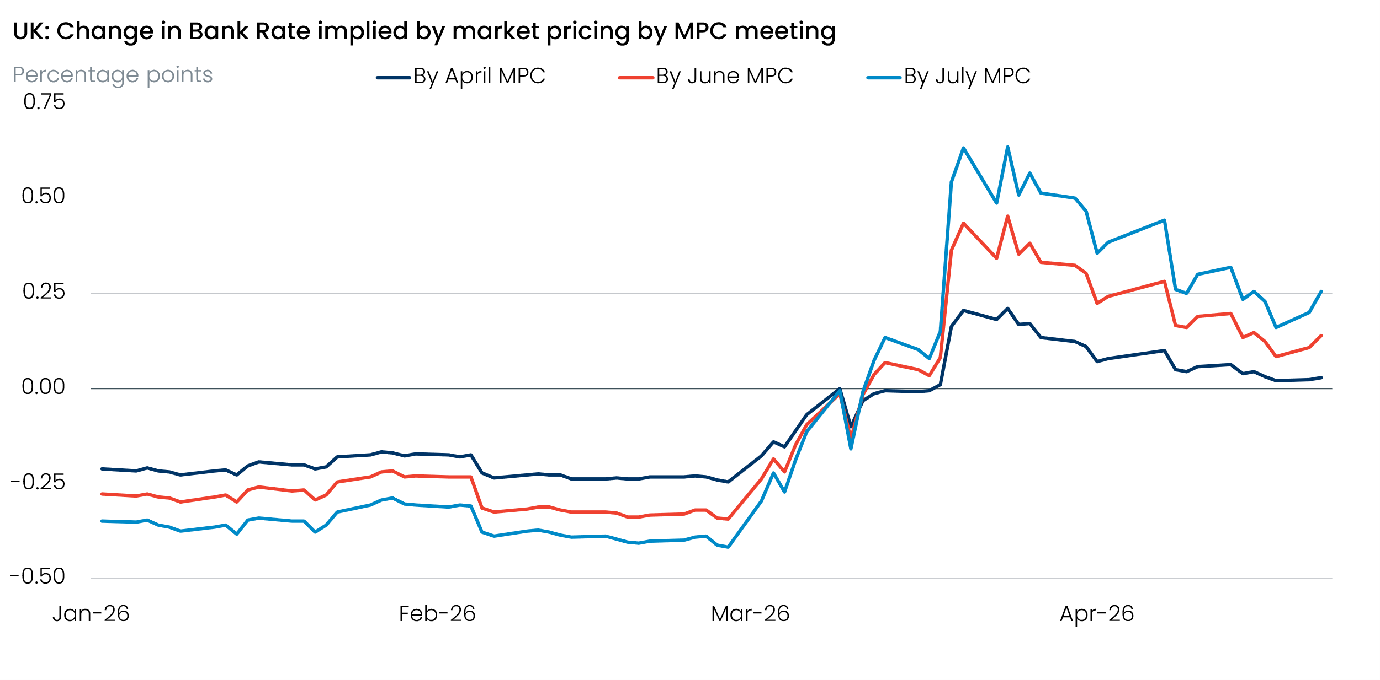
Source: Oxford Economics calculations using data from Haver Analytics
But we suspect April’s vote won’t be a repeat of March’s unanimous decision, with the split likely to be in the region of 8-1 to 6-3. Huw Pill and possibly Megan Greene and Catherine Mann appear the most likely to favour a 25bp rate hike. These members have signalled that they put the most weight on upside risks to the inflation outlook and that they view another prolonged period of inflation overshooting its target as more costly than a scenario in which pre-emptive hikes may have to be quickly reversed if second-round effects prove modest. On this basis, these members have suggested that some early tightening would be preferable to waiting for clear evidence on second-round effects and running the risk that the MPC falls behind the curve.
Of more significance than April’s interest rate decision will be how the committee use their individual paragraphs and a new set of scenarios to signal whether support for a hike over the next 3-6 months is likely to emerge. Our baseline forecast assumes Bank Rate will remain on hold for the rest of the year. The committee will have more information about how the energy shock is feeding through to the economy by the end-July meeting. The MPC will also update its forecast then so, unless inflation expectations rise very sharply in the near term, the July meeting is likely to be the next time there will be genuine jeopardy around the monetary policy decision.

